**Zoom Room Training**

**Scheduling a Zoom Room Meeting**

1. Open the Zoom program.

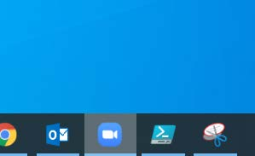

1. Sign into your Zoom account with your credentials.

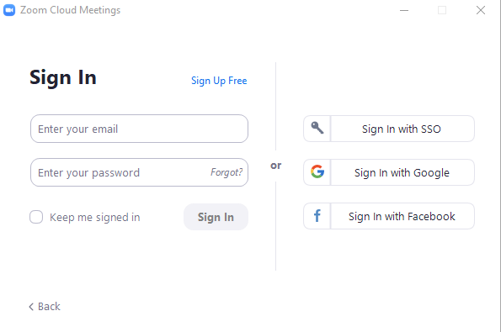

1. Select Schedule.

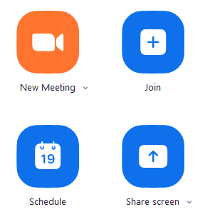

1. Select all of the appropriate options in the window.
   1. Make sure **host video** option is enabled.
   2. Make sure **participants video** option is enabled.
   3. Make sure **join before host** option is enabled (under advanced options).

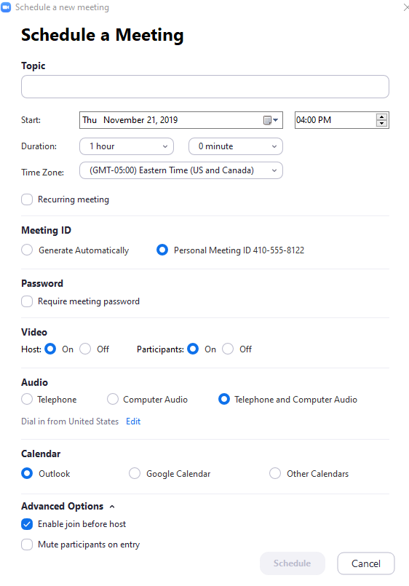

1. Click **Schedule** to be redirected to Outlook/Mail Account
2. Select all the recipients you would want to send an invite to the Zoom Meeting.
3. Click **Send** to email the calendar invite.

**Starting a Zoom Room Meeting**

1. Make sure you have the Meeting ID from your Zoom meeting calendar invite.

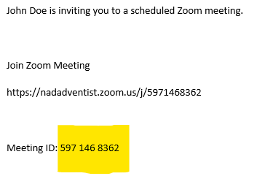

1. Select **Join** on the iPad Control/Wall panel.

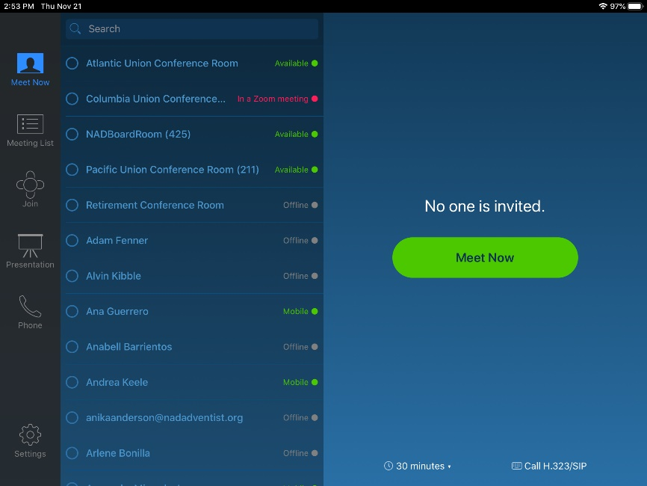

1. Enter the Meeting ID.

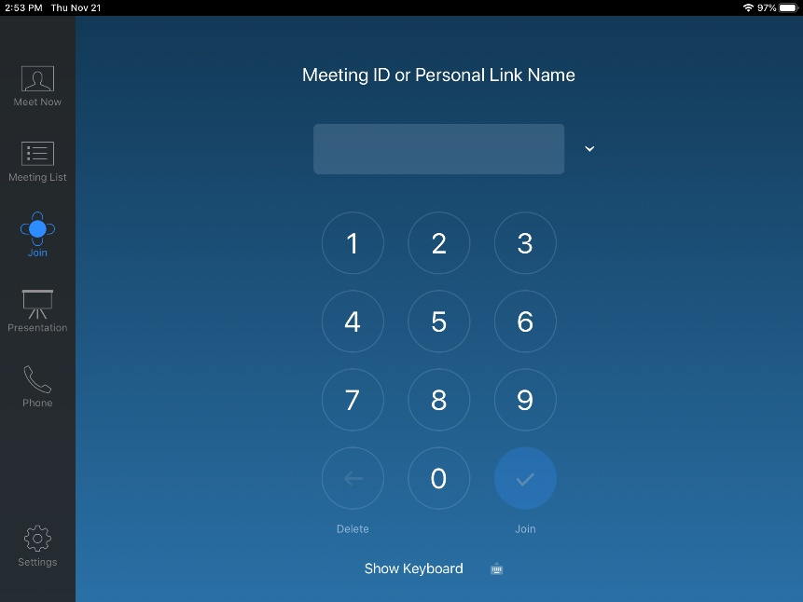

1. Click **Join**.

**Inviting Participants from Zoom Room**

1. Click **Invite** from the iPad Control.

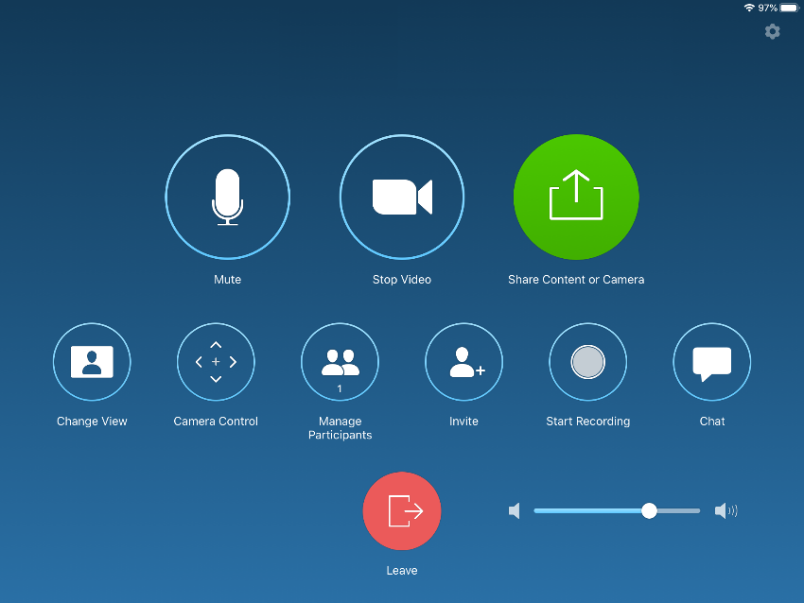

1. Select the **Invite by Email** tab at the top of the screen.

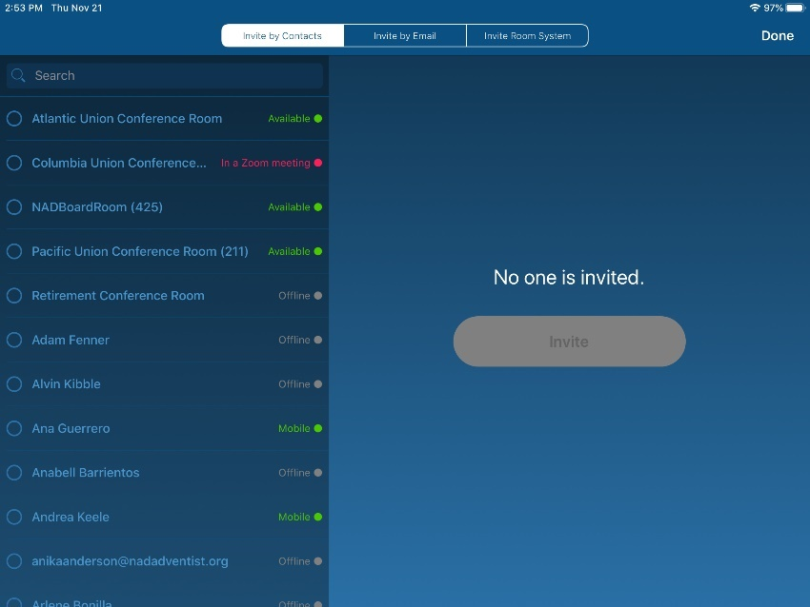

1. Use the on-screen keyboard to enter in the email contact(s) that you are sending an invite to.

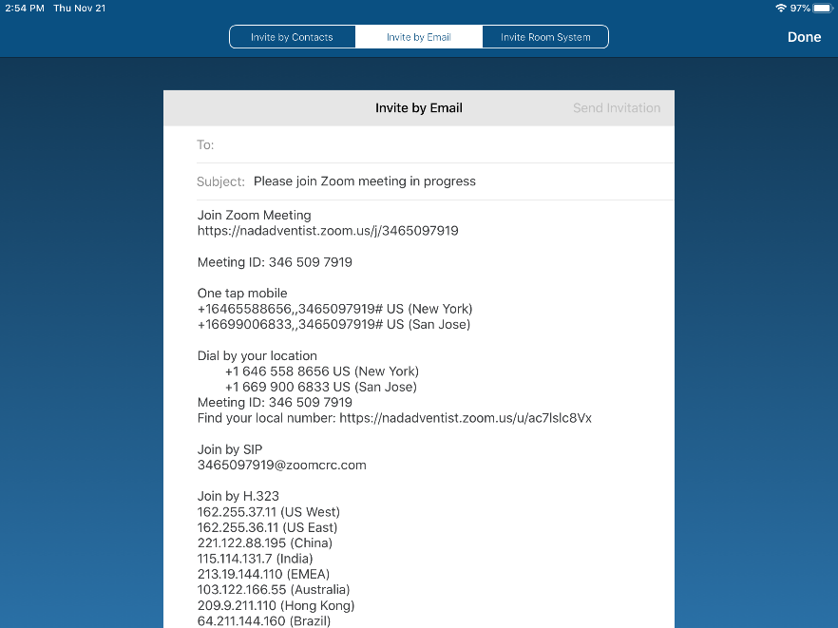

1. Click **Send Invitation** in the top-right corner of the screen.

**Presenting Your Screen – Zoom Program**

1. Open the Zoom program.



1. Sign into your Zoom account with your credentials.



1. Select **Share screen**.



**Presenting Your Screen – Guest (if presenter does not have the Zoom program)**

1. Select **Presentation** from the iPad Control/Wall panel.



1. Choose the option for **Desktop**.

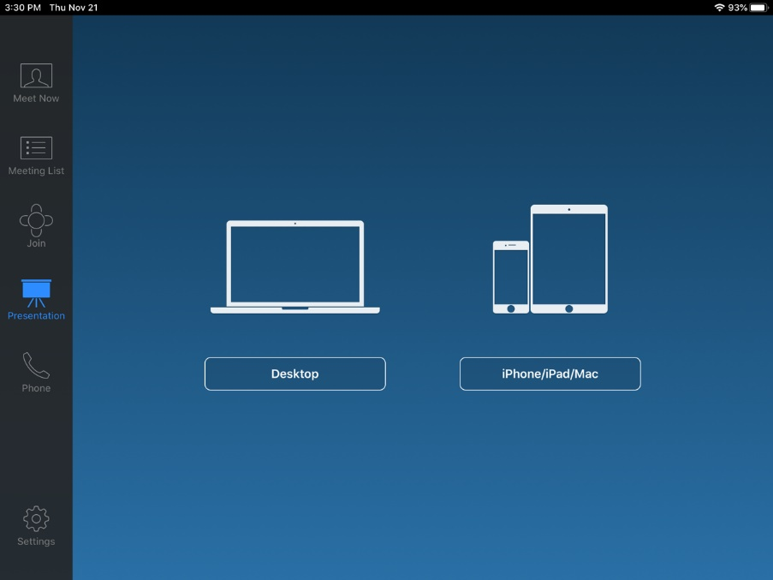

1. Enter the given website page on your internet browser: **share.zoom.us**

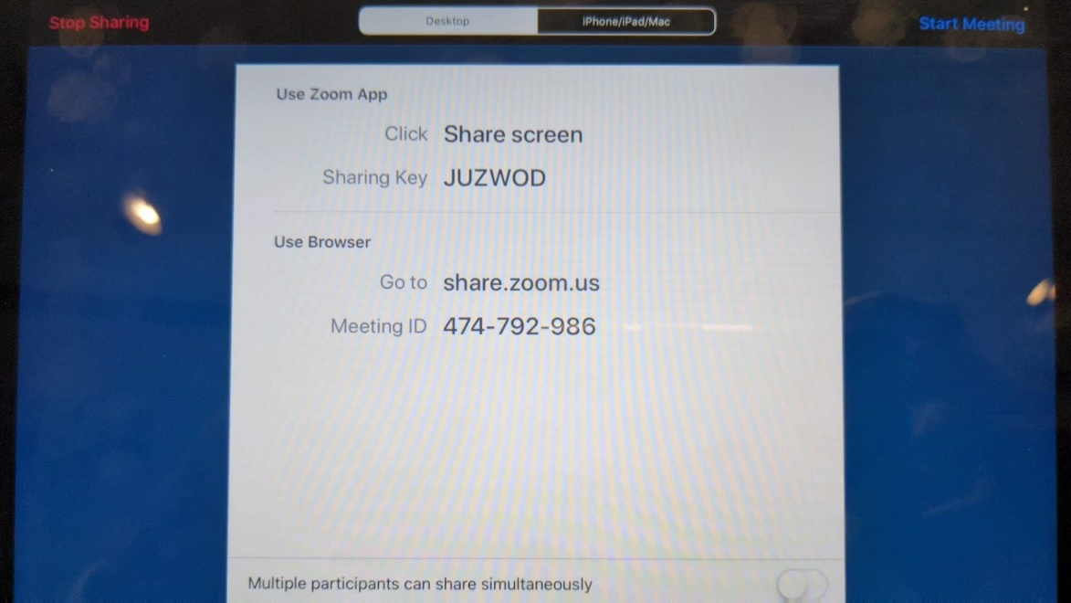

1. Enter in the Meeting ID or Sharing Key.

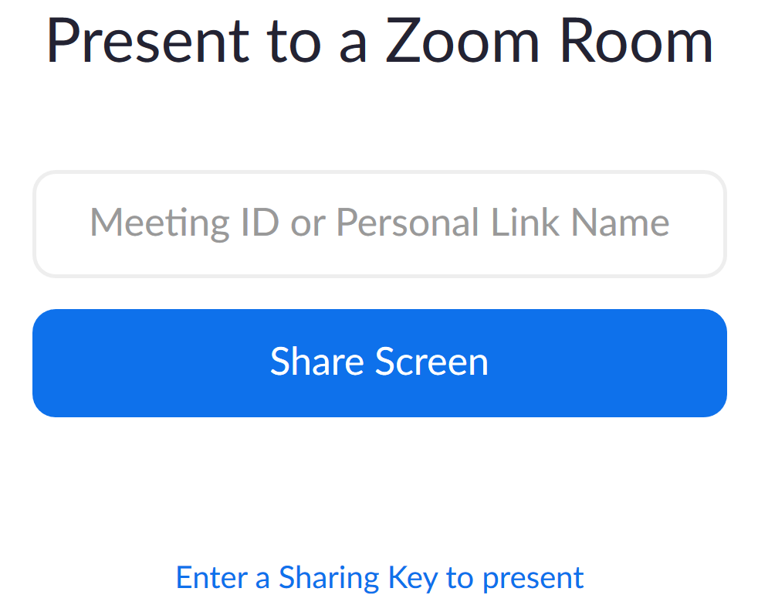

*The laptop user will be prompted to download a small file to run the program.*